Installation Jenkins : Jenkins works on 8080 port we have to enable custom tcp 8080 and anywhere

Install Jenkins on ubantu 24.04

login to aws console launch instance using ubantu 24.04 select security group all traffic and any where
connect instance to mobaxterm using public ip

sudo apt update
sudo apt install fontconfig openjdk-21-jre
java -version

sudo wget -O /etc/apt/keyrings/jenkins-keyring.asc \
https://pkg.jenkins.io/debian-stable/jenkins.io-2026.key
echo "deb [signed-by=/etc/apt/keyrings/jenkins-keyring.asc]" \
https://pkg.jenkins.io/debian-stable binary/ | sudo tee \
/etc/apt/sources.list.d/jenkins.list > /dev/null
sudo apt update
sudo apt install jenkins

sudo systemctl enable Jenkins

sudo systemctl start Jenkins

sudo systemctl status Jenkins

copy publiv ip and paste in google using http://public ip:8080

copy passward and paste in terminall using

sudo cat password paste

password display copy password and paste in Jenkins

install suggested plugins
username password email log in
public ip:8080

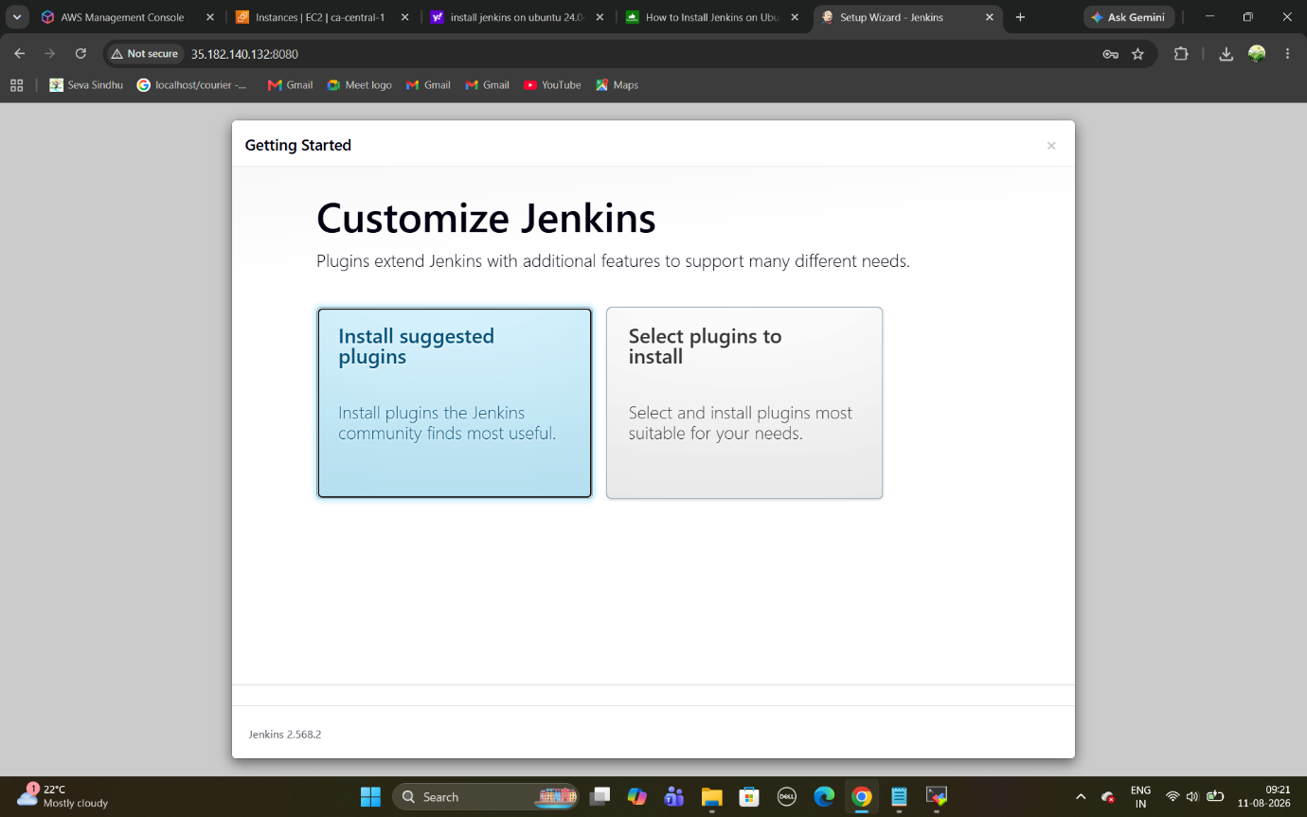

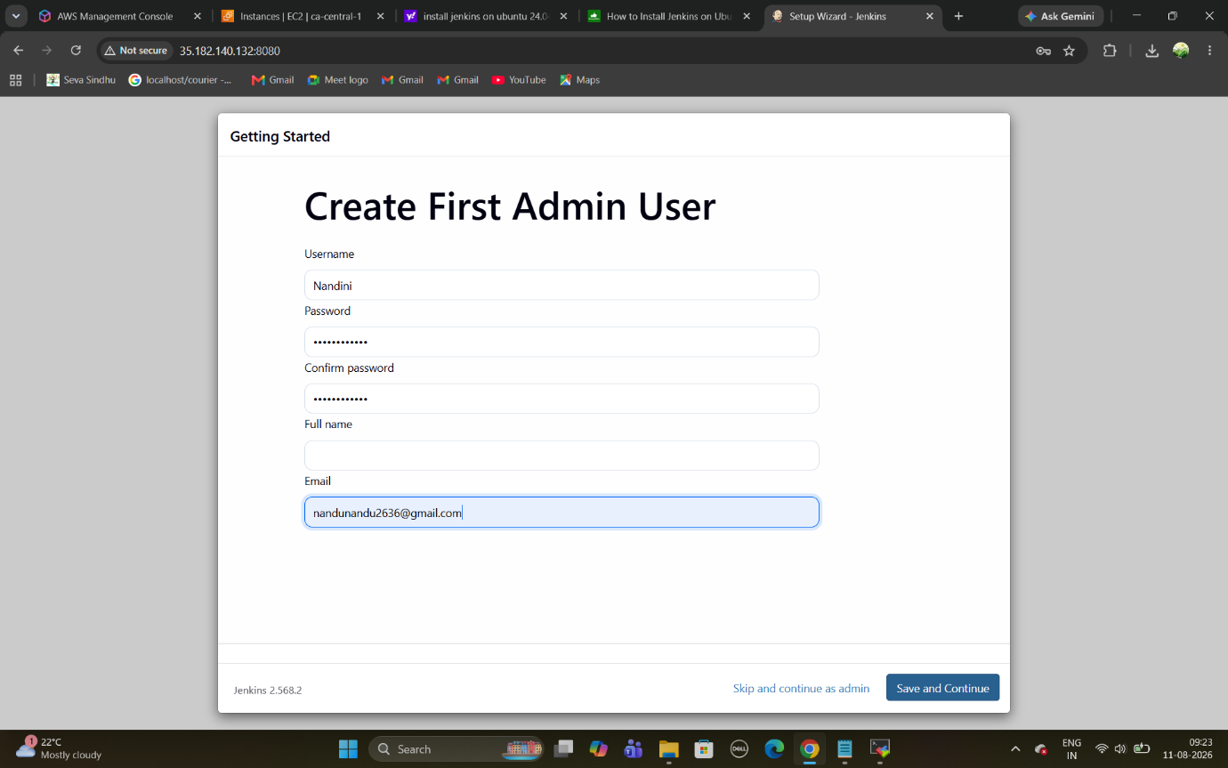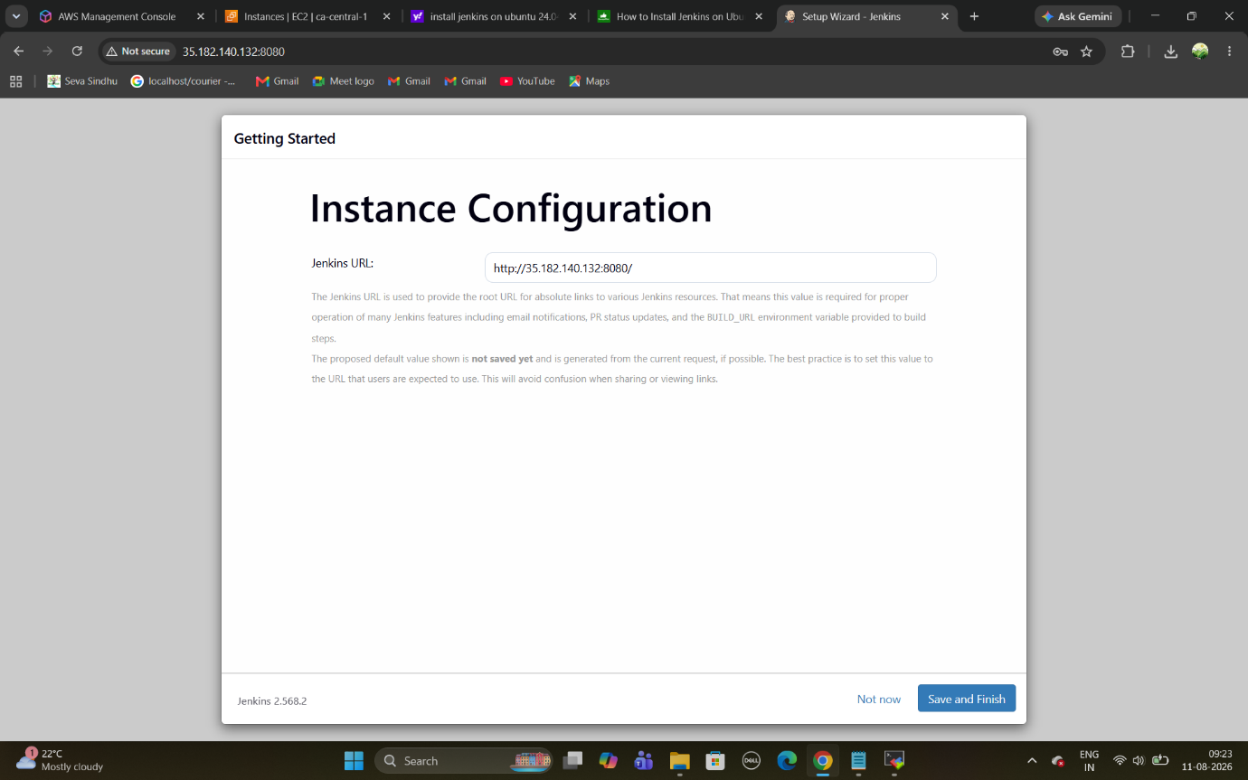
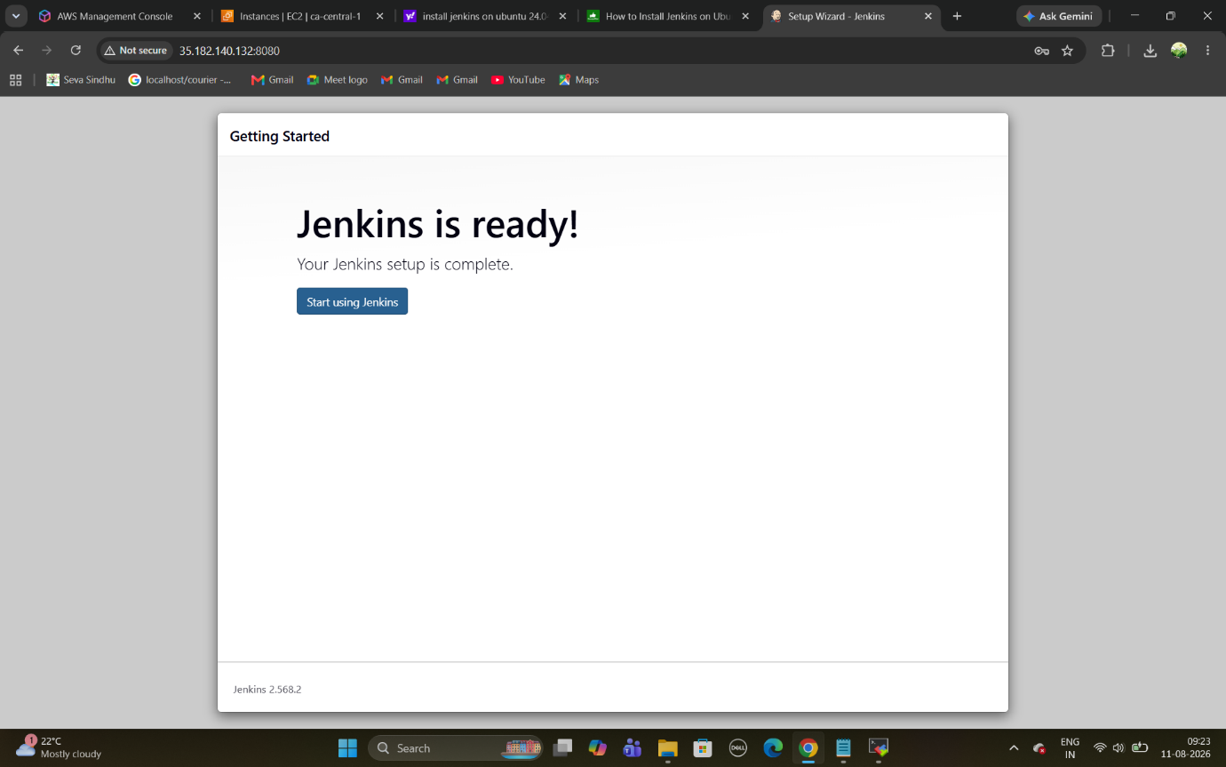

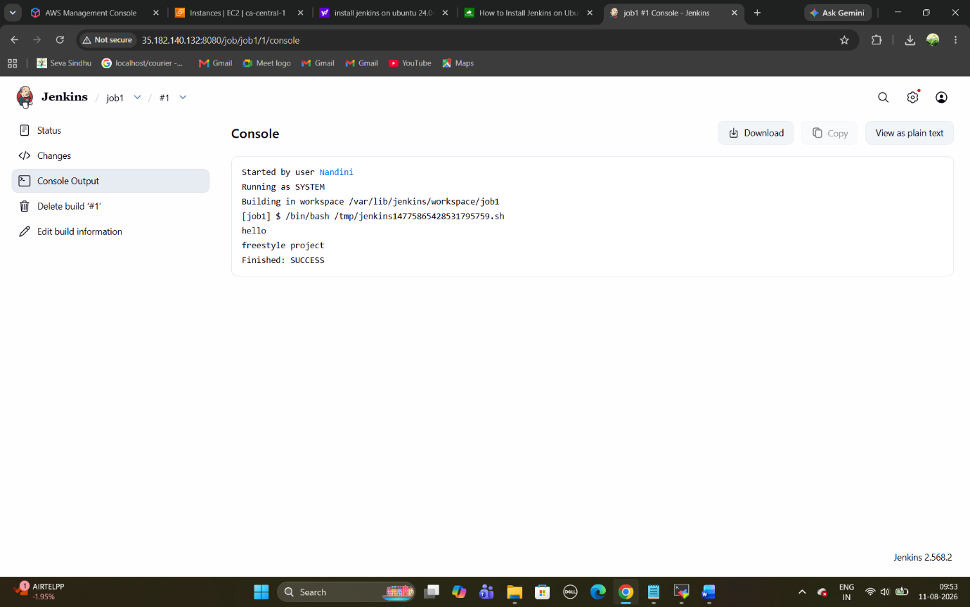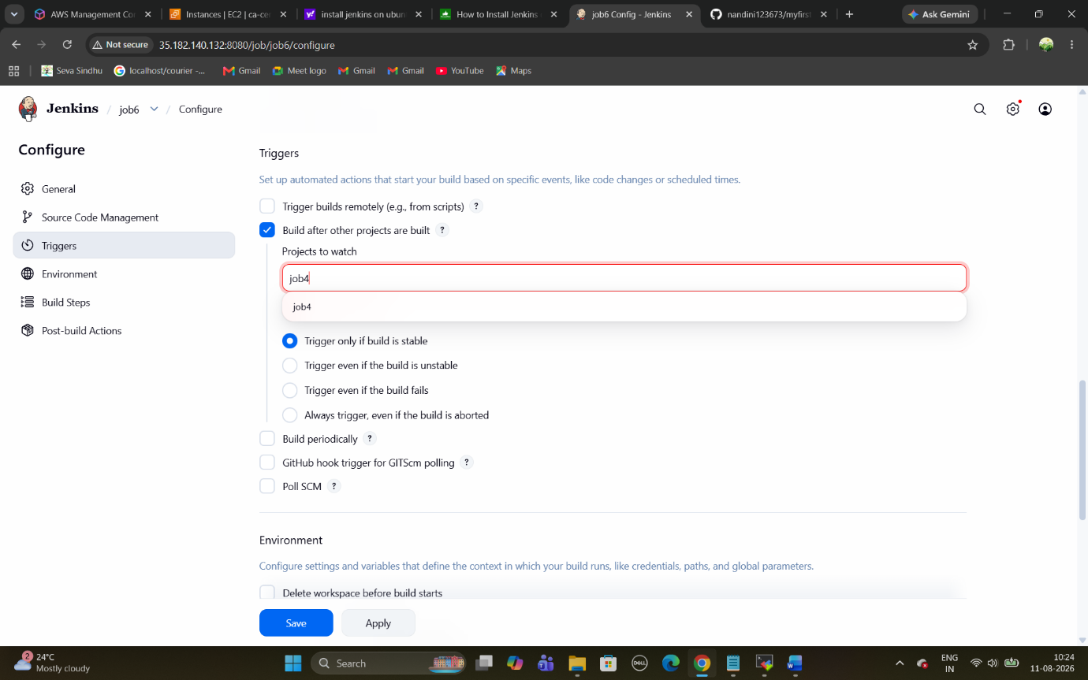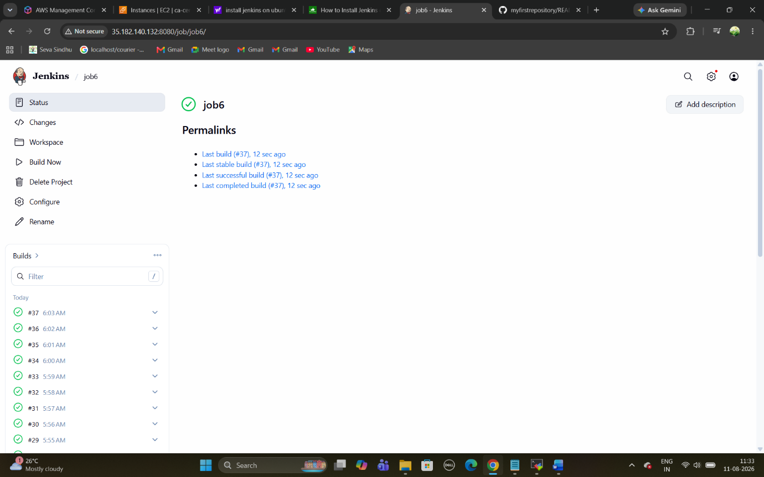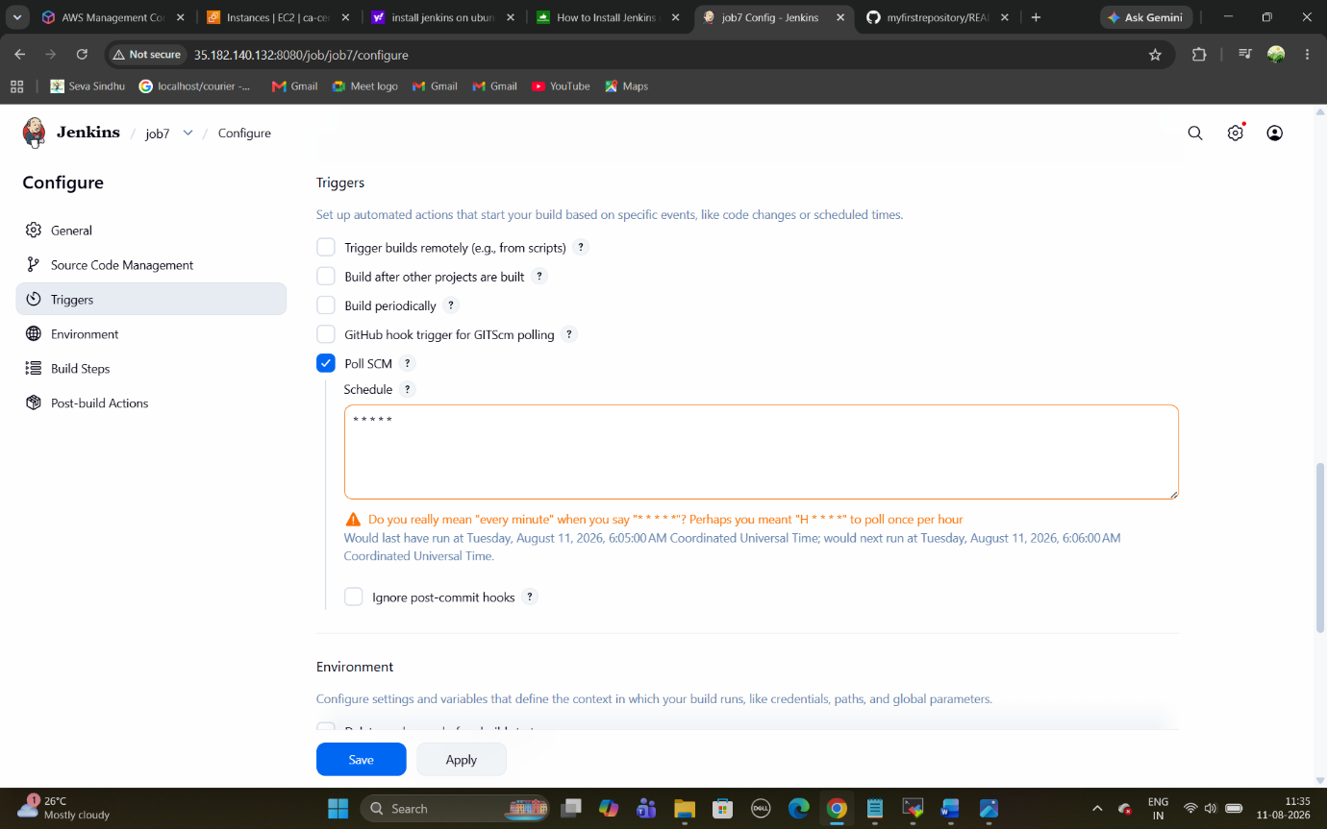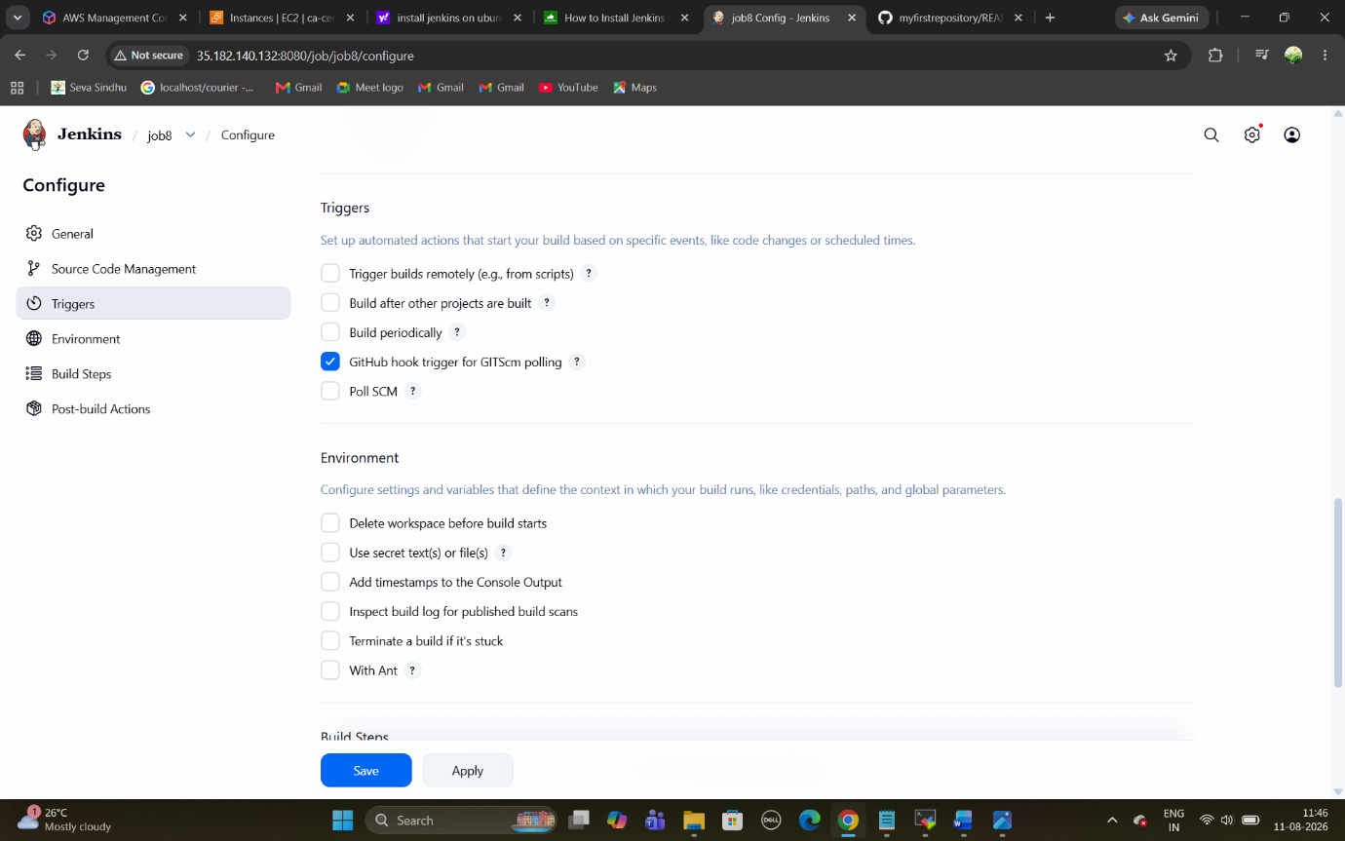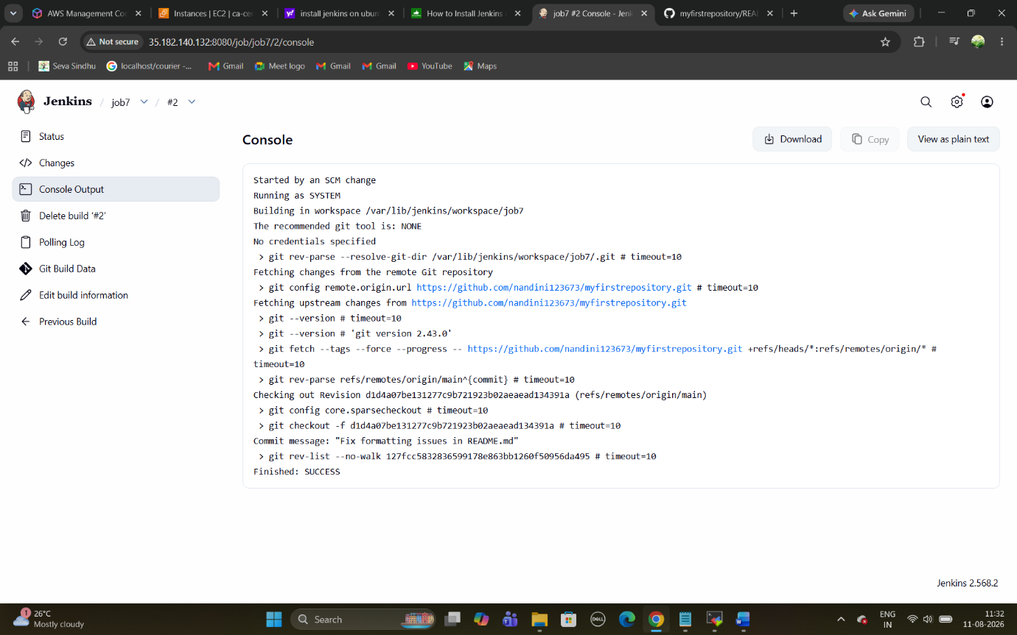

pipeline {
agent any
stages {
stage("clone the code") {
steps {
echo "clone the code using git"
}
}
stage("build the code using mvn") {
steps {
echo "build the code"
}
}
stage("test the code") {
steps {
echo "test the code"
}
}
stage("deploy the code") {
steps {
echo "deploy the code"
}
}
}
}